1、Confirmation of the use of the environment
1) Home security cameras use the environment to have a wireless router, and can access the Internet in real time
2) Support IE browser, Safiri browser, Chrome browser, Firefox browser, Opera browser, etc.;
3) Support for mobile phones: Android (Android4.0 or more, CPU frequency 1GHz above), IOS (5 or more)
2、Installation and configuration
Step 1: connect the device to the power supply
Step 2: Download and install hand monitoring software
1）.In the Android (Android Market) or apple (APPStore) search for HomeC to download;
2) .Mobile phone monitoring software to get the mobile phone monitoring software to download.

Android IOS

3. After installation, pls connect your mobile with Wifi and run the software, then register an account by click “Regrister” button.
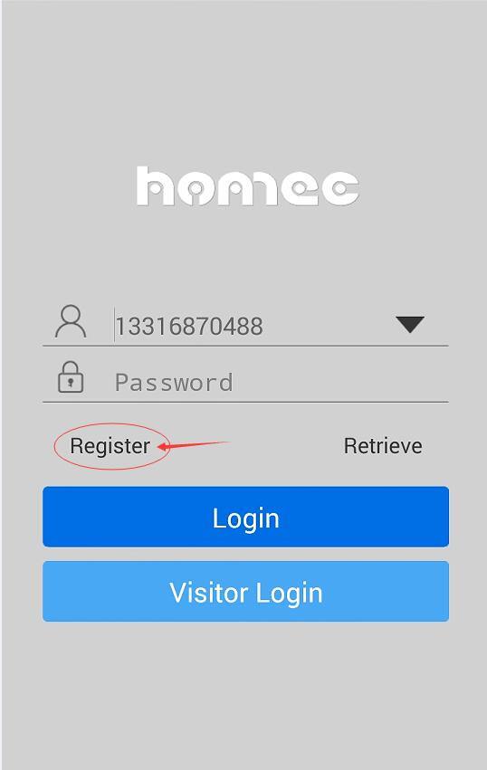。
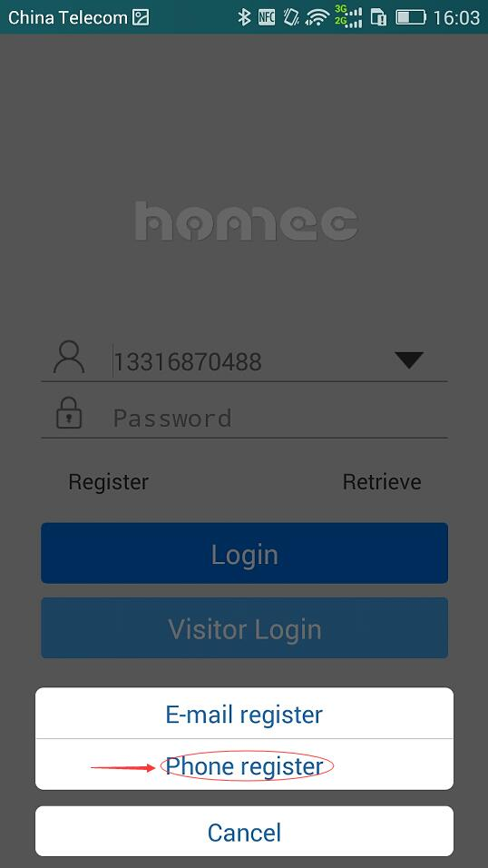

You may register by using your mobile or email, the following is taking mobile register for example:
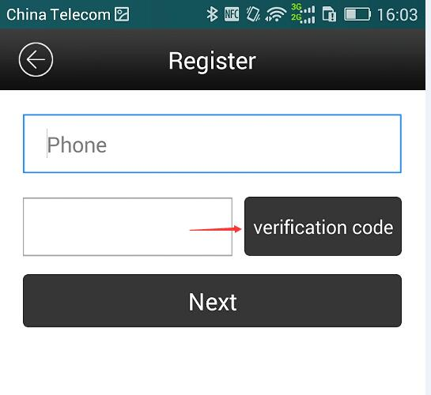
Input mobile No., then click” verification code”, then you will get the code, then click “ Next”.

4. After finishing reinstate, pls login by using the account we reinstated, shown as follows:
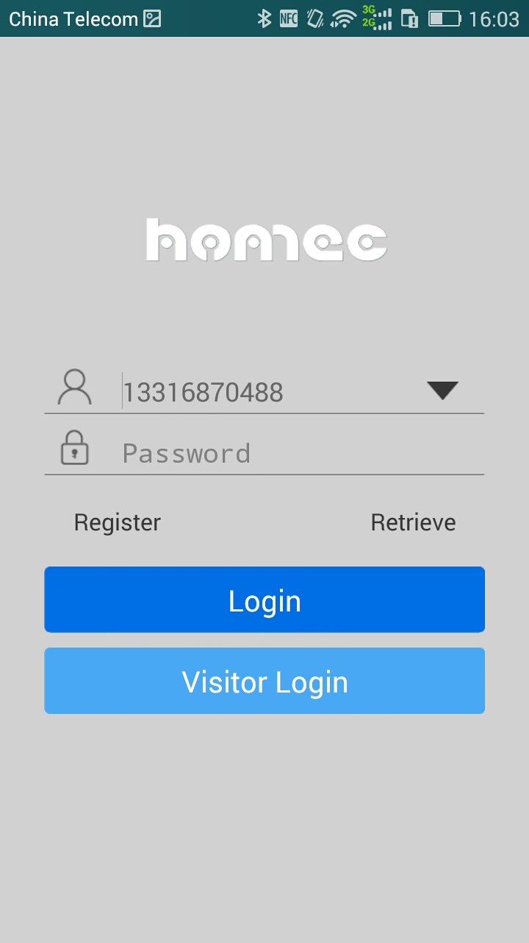

5. After login, pls add the camera
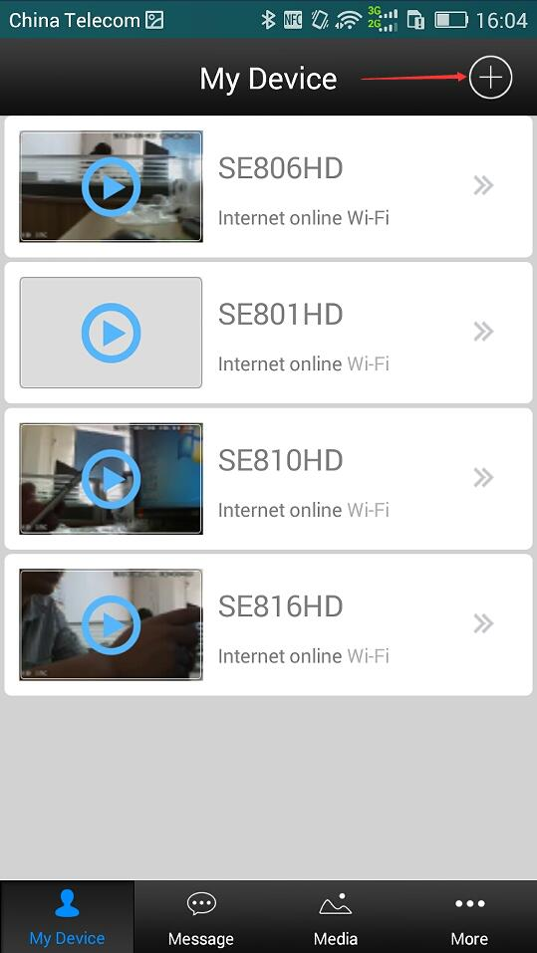 A. ：Click “+” as below
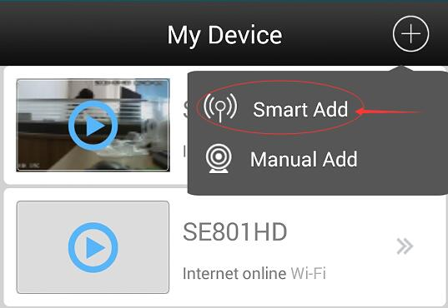 B.：Select “SMART ADD”
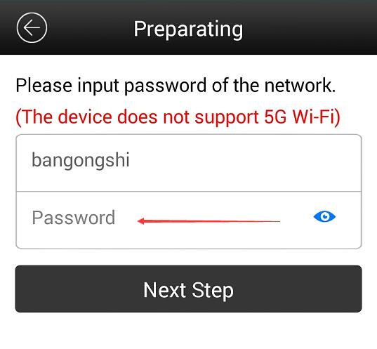C：Type your wifi password

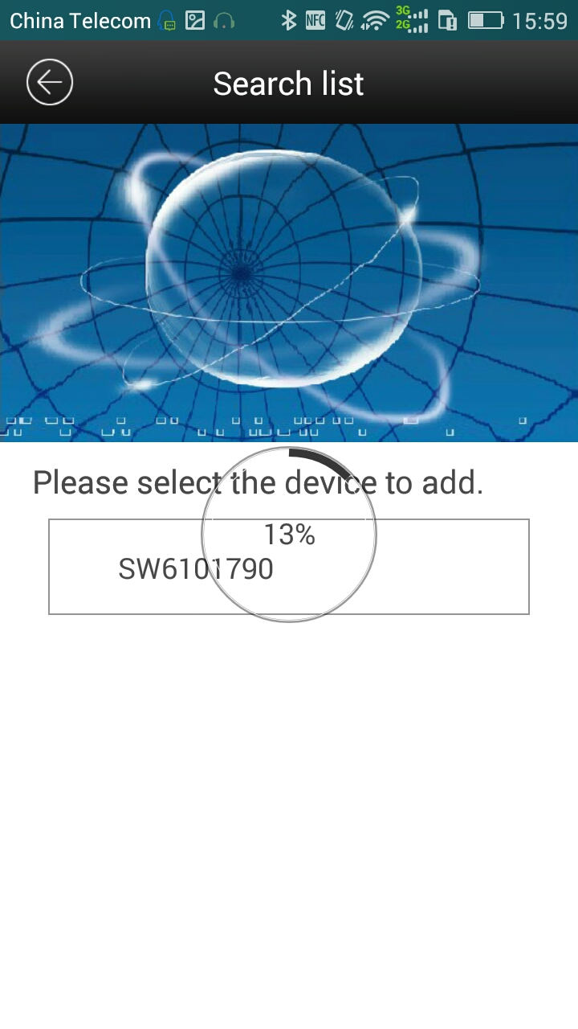
D：It will search your cameras automatically, pls wait for 100% processing. Then click the searched camera to finish adding camera operation.

Pls click play button to open the video点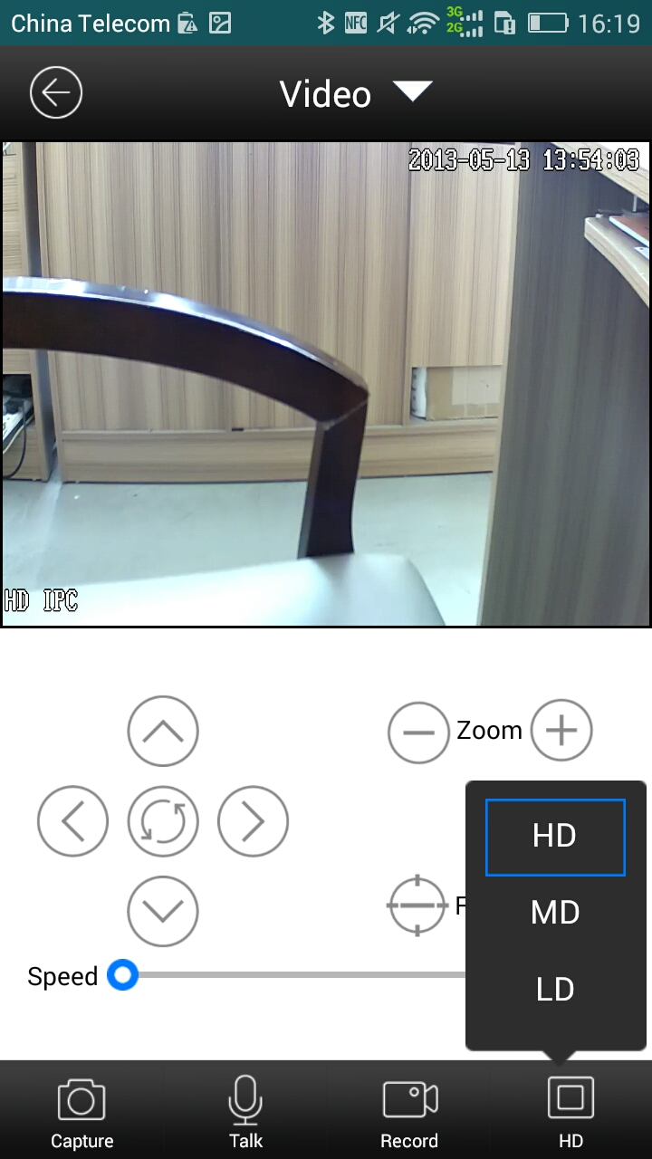 After opening the video you may select the resuolution according to your network enviorment, if good, you may select “HD”, if bad, you may select” LD” .

Buttons in the GUI function instruction:
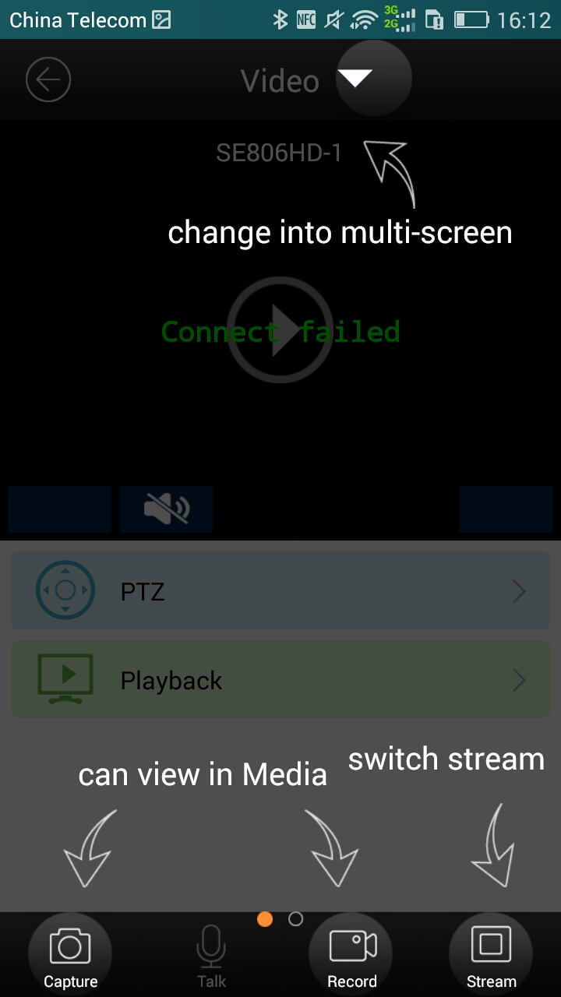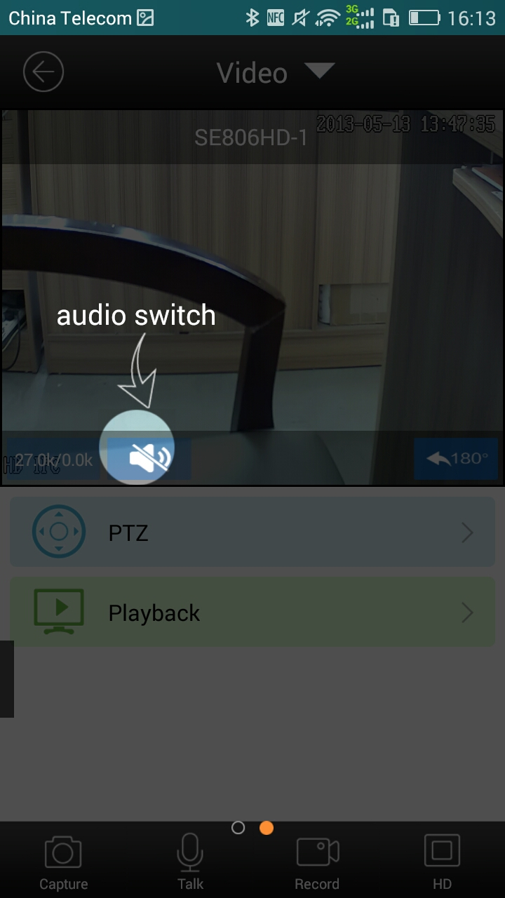
Rotate your mobile, it will shift to full screen：
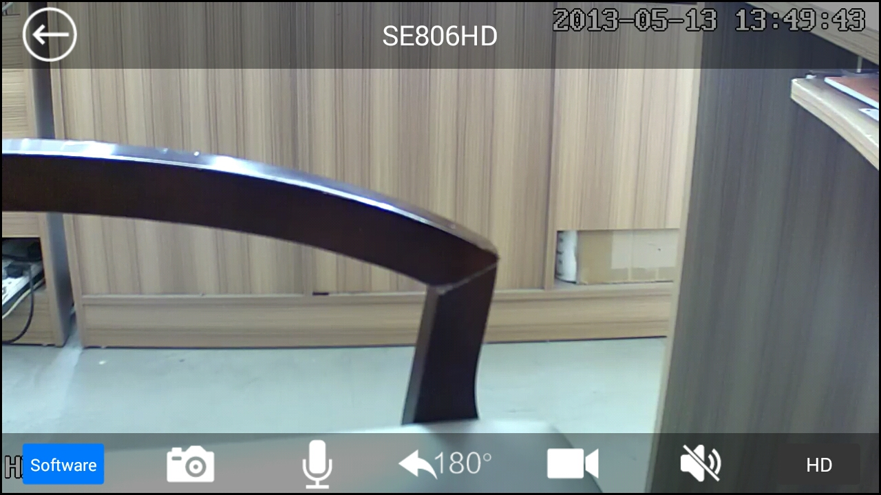

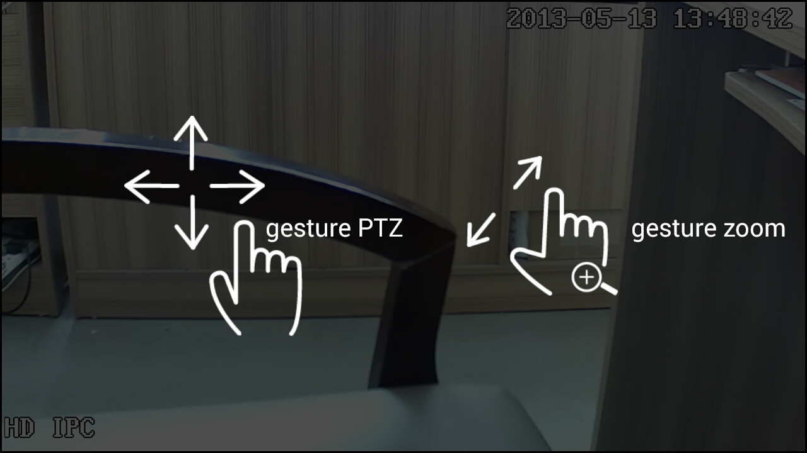

Motion detection alarm setting：
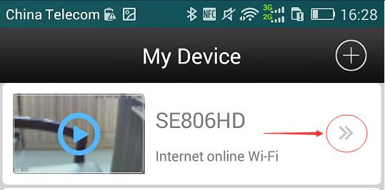 Click the button 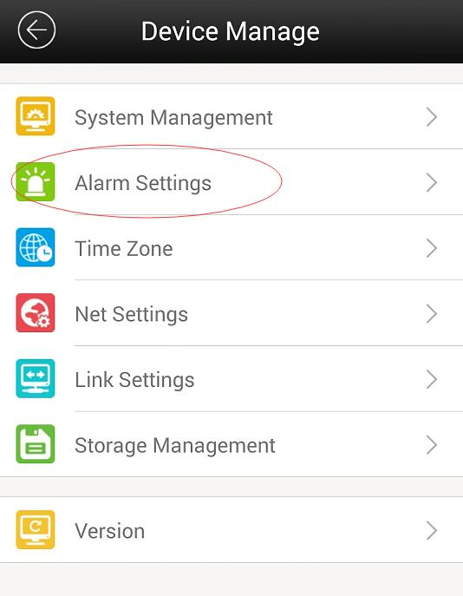 Click“Alarm settings”
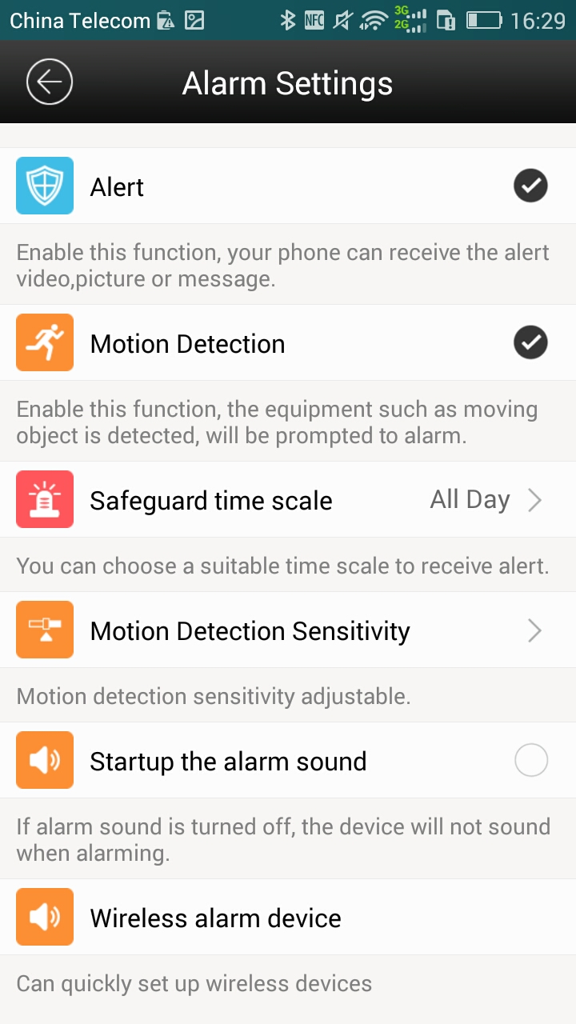 Select“Alert”and“Motion detection”

If you need other functions, you may select accordingly.

Mobile alarming receiver setting：
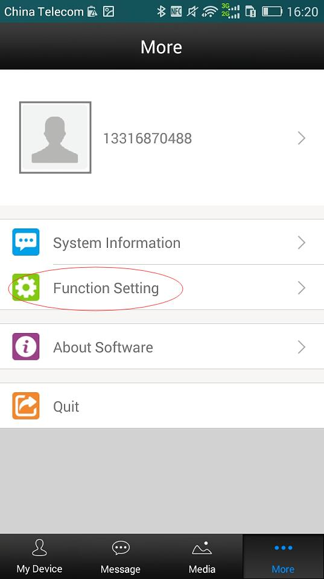Click“MORE”，Select“Function Setting”
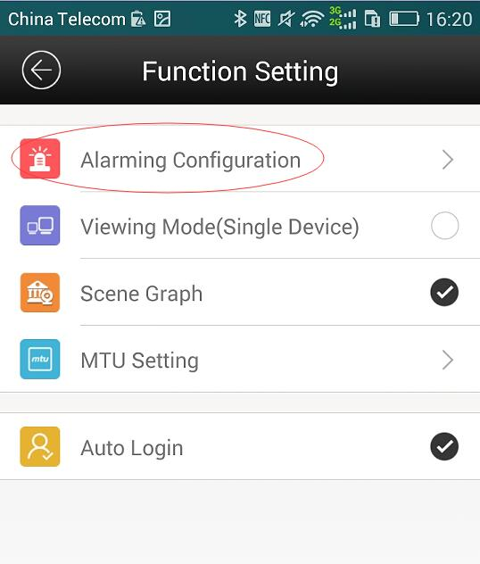Select“Alarming Configuration”

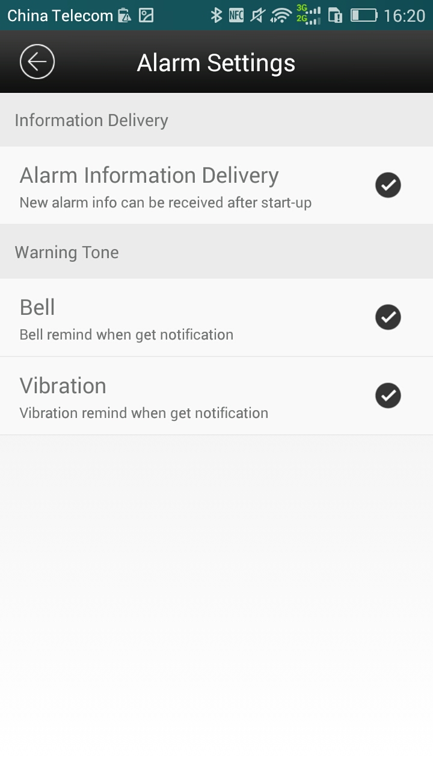 Select and initiate the need function, “Alarm Information Delivery”must be selected , or cannot get the alarming by mobile( Pls keep your mobile network in good condition

